**Continue Setup**

Justice Escalante

Linux Admin

**Checking your repositories**

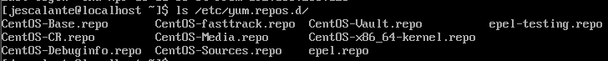

To check your repositories in **CentOS** is a tad bit different compared to standard distros. For **CentOS** using the command yum repo list will display all your current repositories, for non-enabled repositories yum repo list all does the trick. If you want to enable these repos you would have to navigate to your repositories that should be around ***/etc/yum.repos.d/*** and find the file(Screenshot above). After this simply open it up with vim or a text editor, proceed to change the ***enabled=0*** parameter to 1 to enable it proceeded by ***yum clean all*** and then ***yum repolist*** to make sure it got enabled correctly. To add a repo for both PPA and official you can use alien(ppa) or config-manager(official). For PPAs in ***CentOS***, the installation of alien is key as PPAs are generally not supported on ***CentOS***. To install them properly, alien will convert the PPA to a rpm which can be installed. Using the command ***alien --to-rpm insertpackagename.deb*** this is possible, make sure to check your repo list after to make sure it was added accordingly. Official repos are a lot easier to add, this can be done by simply using the config-manager operand as ***yum-config-manager --add-repo=http://example.com/myrepo***: simply swap out the last bit [***http://example.com/myrepo***](http://example.com/myrepo)with ***what you desire***. If installing packages, you can test if everything is working by using ***yum search packagename,*** you will get an error indicating why if unsuccessful. Anything above has been done/checked on 4/26 as well.

**Installing Tmux, Fail2ban, and emacs**

After looking through these programs, it seems that **EPEL** repository is needed for installation as this is not provided default by **CentOS**. To see if the repository was installed correctly, you can use ***yum repolist*** and see if your repo is there. In the screenshot above the command ***sudo yum install epel-release*** is used to do so as of 4/26/23, **EPEL**= Extra Packages for Enterprise Linux. Now that the extra needed stuff is out the way, we can simply install each program/utility using ***sudo yum install***.

**fail2ban**

**Fail2ban** has great settings such as ***Bantime***, ***Maxretry*** and a few others like ***Logpath,*** and ***FindTime***. These range from how long someone is banned for(***bantime***), their amount of retrys(***Maxretry***) and even how long between a retry until an ip is banned(***Findtime***). For this instance, I have left the settings at default until further notice.

Installing with ***sudo yum install fail2ban***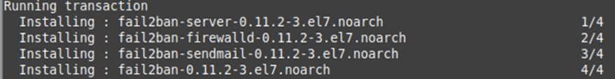

When open you can edit the config file called ***jail.conf*** located at ***/etc/fail2ban/***, there’s plenty of settings to test like **bantime**. Highly suggest you make a copy just in case. More commands/settings: <https://www.fail2ban.org/wiki/index.php/Commands>



Now you would have to enable **fail2ban** with the commands ***sudo systemctl enable fail2ban***, and ***sudo systemctl start fail2ban***. You can check if **fail2ban** is running properly by checking its status as shown above. Above the status is checked before and after startup. Now to really test it you could get yourself banned by multi attempts. To see who’s been banned including yourself if you test it, use ***grep ‘ban “ /var/log/fail2ban.og***: **grep** is needed as this log doesn’t have just bans inside.

**Tmux**

Installing with ***sudo yum install Tmux***

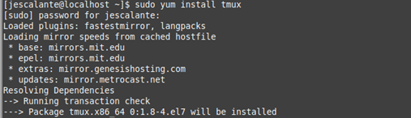

Now to see if **tmux** worked, using ***tmux new -s SESSIONNAME*** would be proper format, below I have used test as a name, and you can see the multiple sessions that are green. To open a new tab/session you can use ***Ctrl b*** followed shortly after with a ***c***. To navigate ***Ctrl+b*** followed by your respective tab number. **Tmux** new-window is also a great way to add tabs/windows. There is a lot more settings that you can find here: [https://wiki.archlinux.org/title/tmux](https://linuxhint.com/cowsay-linux-command/)

To quit, use ***tmux detach*** or ***:kill-session in tmux***. Now to join back the same session you can simply put ***tmux attach -t SESSIONNAME*** and navigate around.

**Emacs**

Emacs can be installed with ***sudo yum install emacs***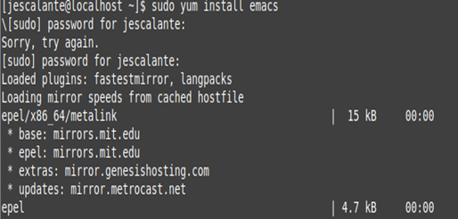

Now to open **emacs** simply use ***emacs FILENAME***

Here we have a test to see if emacs is working properly. To do this we used the command ***Ctrl+s*** as we can use it to search. Above is the text **cat** used as an example. To quit emacs simply use ***Ctrl*** held shortly followed by an ***x*** and ***c*** , hang tight because it will have you verify to quit and save.

**Installing fun tools like cowsay or lolcat**

**lolcat**

Installing with help 4/26/23

With the use of a package manager called ***Rubygems*** can install **lolcat** with ***sudo gem install lolcat***, as ***CentOS*** didn’t have **lolcat** by default. Yum and Ruby are both package managers, but one is mainly for Red Hat(***CentOS***) and might have restrictions unlike Ruby. Above the screenshot shows you how you could check if done correctly by ***using* echo *“TXT” | lolcat***. There is a cool example of **lolcat** below

**cowsay**

**cowsay** can also be added by ***sudo yum cowsay***

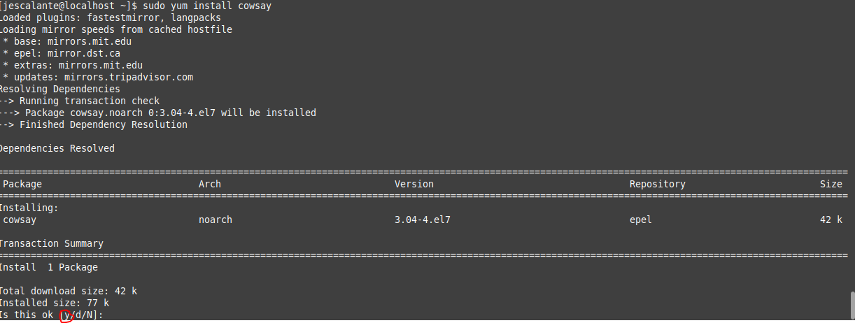

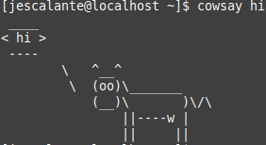

Unlike **lolcat** CentOS had **cowsay** by default so **rubygems** was not needed for full install. Above you can see after installation **cowsay** was tested with ***cowsay hi***, and it worked perfectly! **cowsay** also has other images/characters that can be seen here:

<https://linuxhint.com/cowsay-linux-command/>

**Update VI to vim, update your servers if it’s needed.**

For this example, we first need to look if vim is installed, if not so we can add it properly. Using ***vim –version***, we can see if it’s installed as it will pull its version if installed, or tell you command not found if its not. If not installed ***sudo yum install vim-enhanced*** will do the trick on **CentOS**, above you can see what would happen if its installed already and its results on 4/26/23.

**Bibliography**

**https://www.youtube.com/watch?v=kgdoVeyoO2E**

**https://www.youtube.com/watch?v=Ivggw8qBbHM**

**https://docs.fedoraproject.org/en-US/epel/**

**https://ostechnix.com/find-list-installed-repositories-commandline-linux/#:~:text=2.-,List%20installed%20repositories%20in%20Linux%20using%20inxi%20utility,command%20line%20system%20information%20tool.**

**https://www.youtube.com/watch?v=mTWuhK-2Up8**

**https://www.youtube.com/watch?v=bZ91uYDHuKk**

**https://centos.pkgs.org**

**https://linuxize.com/post/how-to-install-rpm-packages-on-centos/**